Interaction Types and Interaction Modalities
Interaction Types - describes convention for a user to interact with an app/system.
- 4 types of Interaction
  - Instructing:
    - Users issues instruction to system
    - 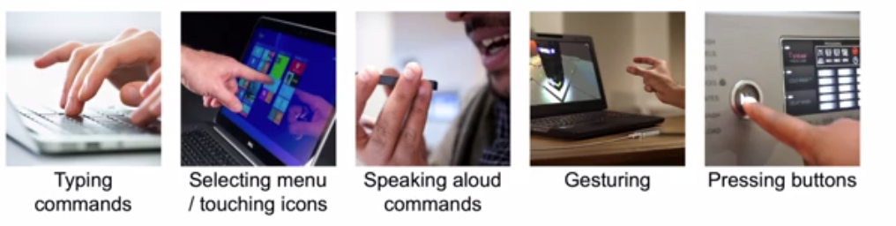
    - New recent type - Voice type
  - Conversing:
    - User have dialog with system
    - 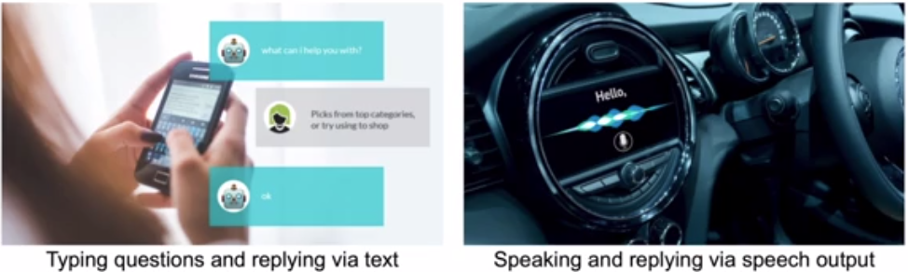
    - Also chatbox and automated help system
  - Manipulating:
    - User interact with objects in a virtual or physical space by manipulating them
    - 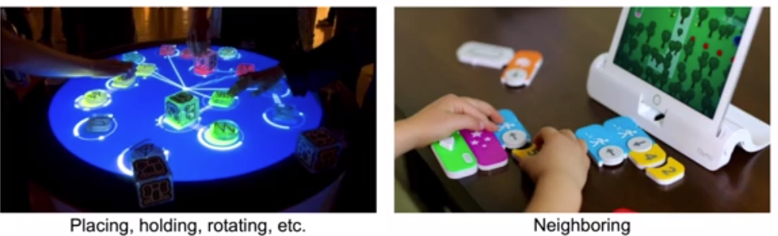
  - Exploring:
    - User move through a virtual environment or a physical space
    - 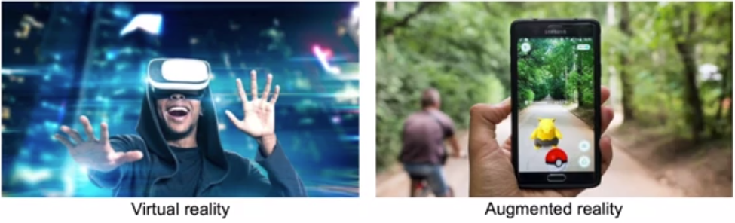
Interaction Modalities - is the classification of a single independent channel of sensory input/output between a computer and a human.
- 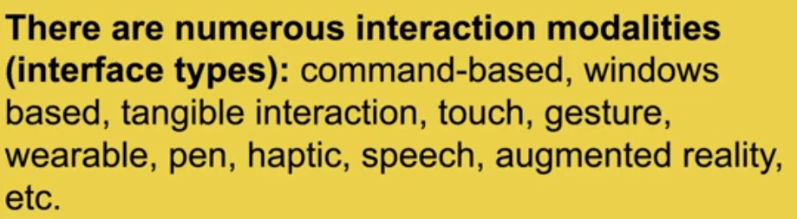

- Command Line
  - 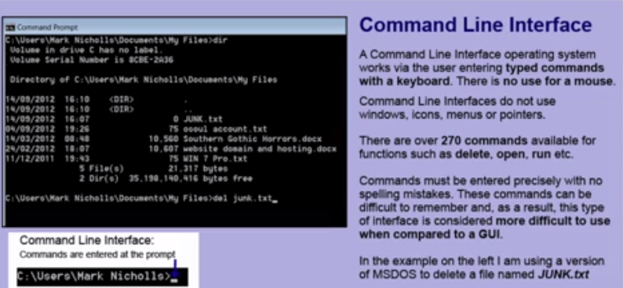
- WIMP
  - 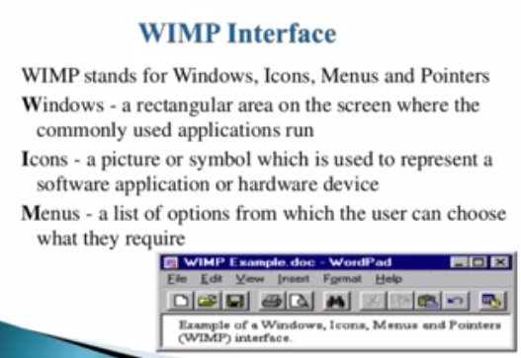
- Multimedia
  - Similar to WIMP
  - Android Auto/ Apple Airplay
- Virtual Reality
- Information Visualization
  - 
- Appliances
  - 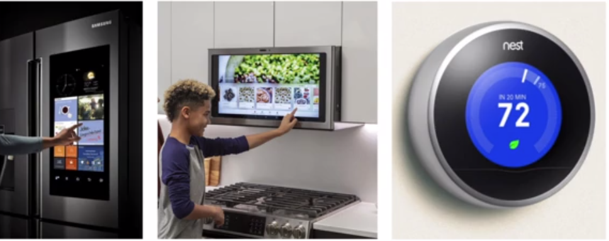
- Mobile (devices)
  - 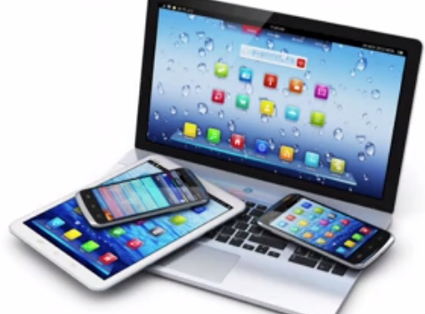
- Speech
  - Voice assistant
- Pen
  - Samsung S Pen
  - 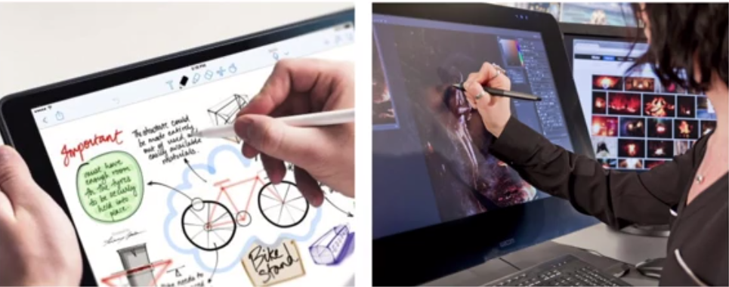
- Touch Interface
  - Touch screens
- Mid-Air Gesture
  - 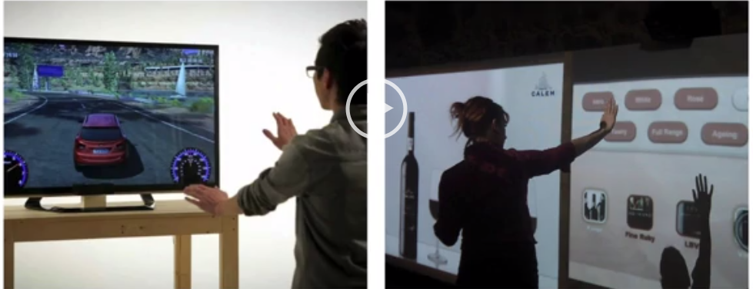
- Haptic (feedback)
  - Feels sense of touch when interacting
  - 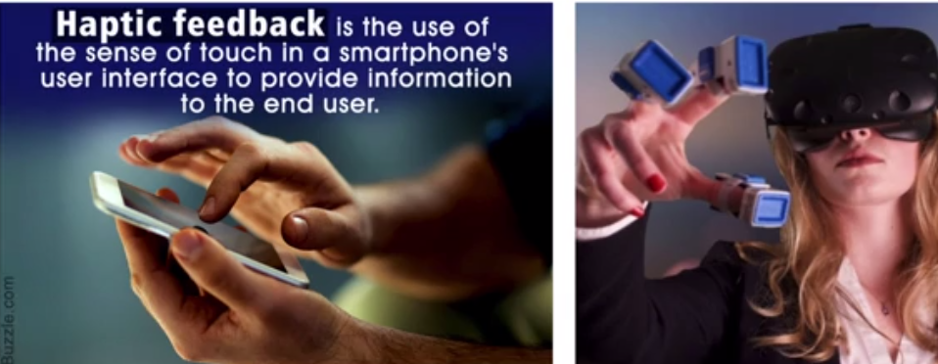
- Shareable
  - Multi-input
  - 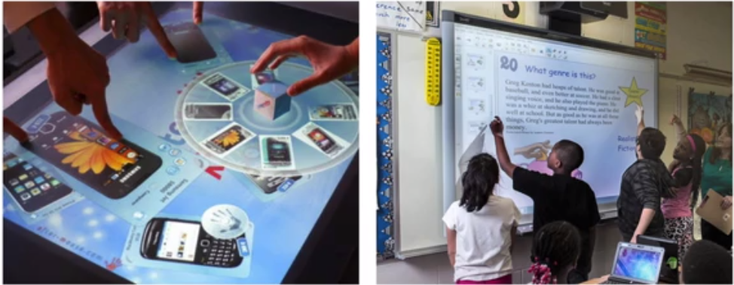
- Tangible
  - 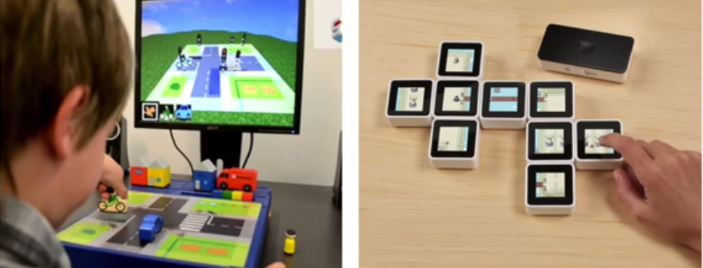
- Mixed Reality
  - 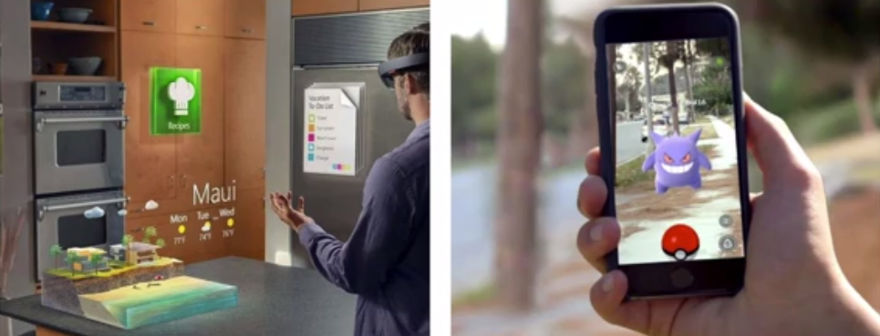
  - AR (Augmented reality)
- Wearable
  - Samsung, Apple Watches
- Robotic
  - 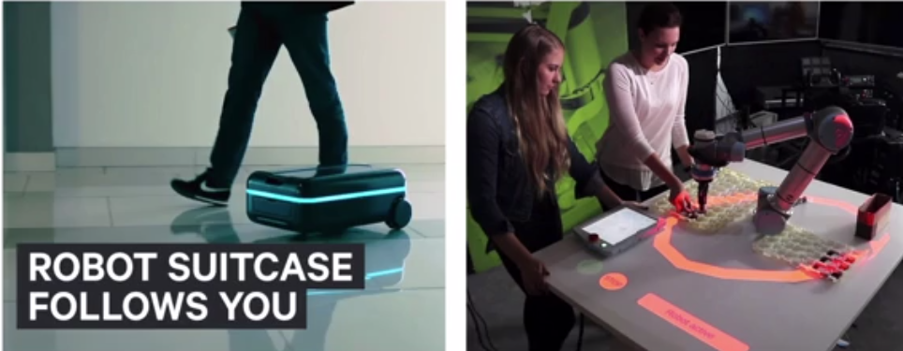
  - Sense world around them to interact
- Brain-Computer
  - 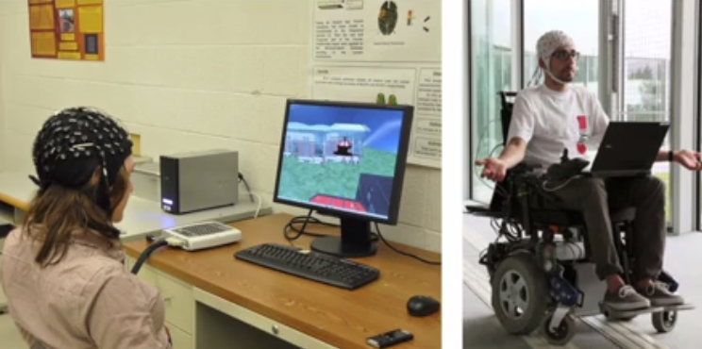
  - Control by brain waves
- 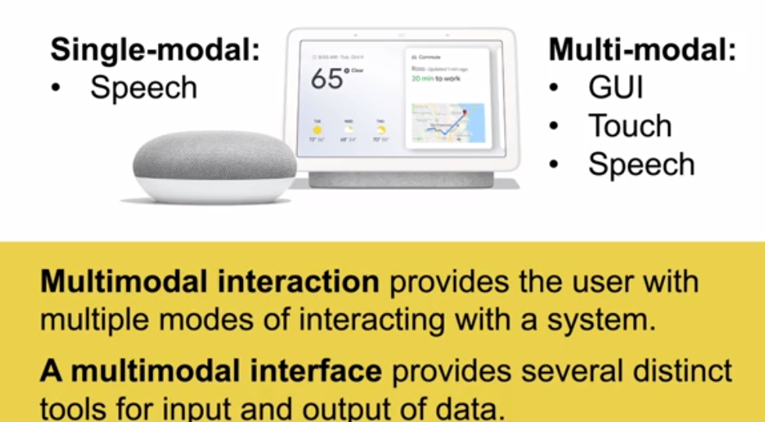
- Multi-modal is more common now

Direct Manipulation Interfaces
- Gulf of Execution - how does user know what to do
- Gulf of Evaluation - how does user know what happen

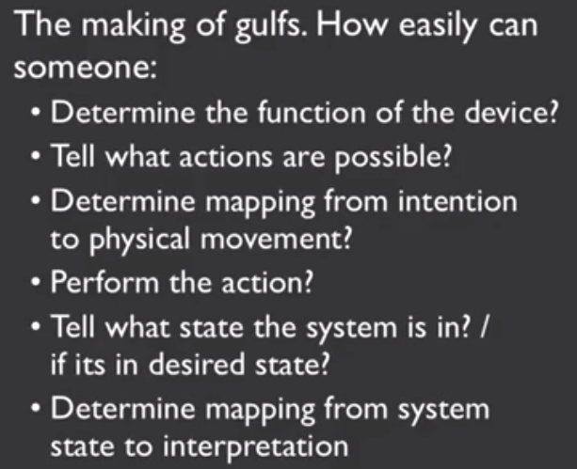
The Gulfs, Affordances, Signifiers, and Metaphors

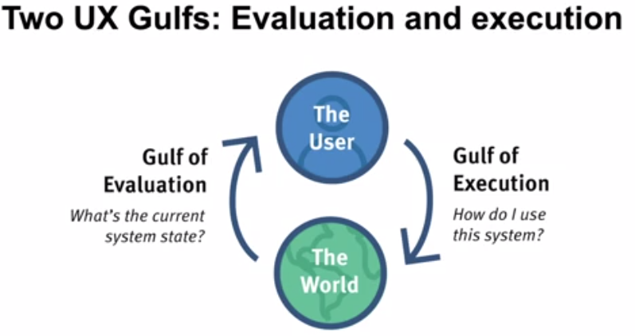
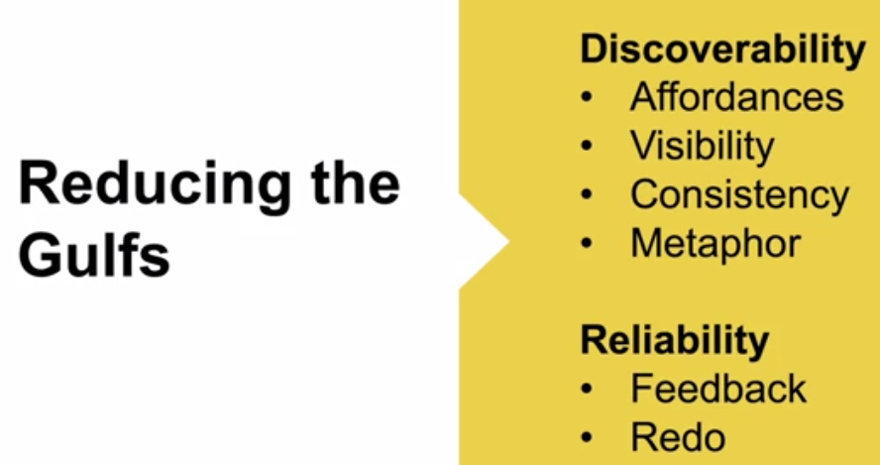
- Affordance: is an relationship between a property of an object and the capability of a person to determine how to object could possibly be used
  - 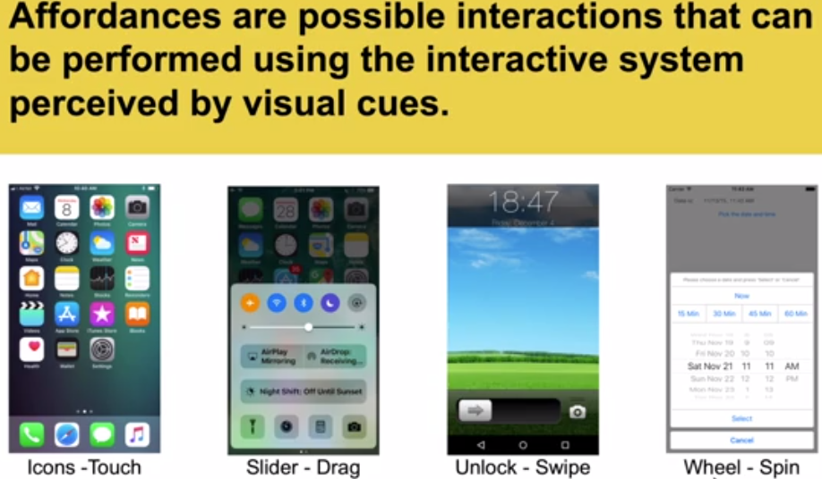
- Signifiers: is a visual, audible, or physical signal for an affordance. Signifiers is a designer's way of communicating an affordance to the user.
  - Example - physical Signifiers
  - 